# Pipeline change

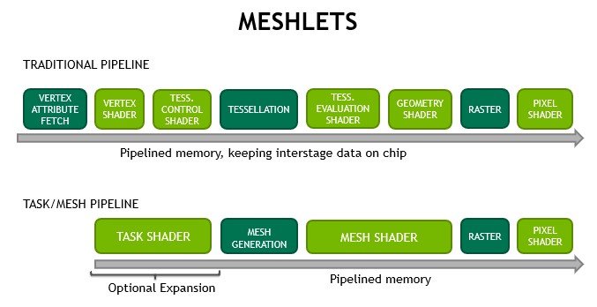

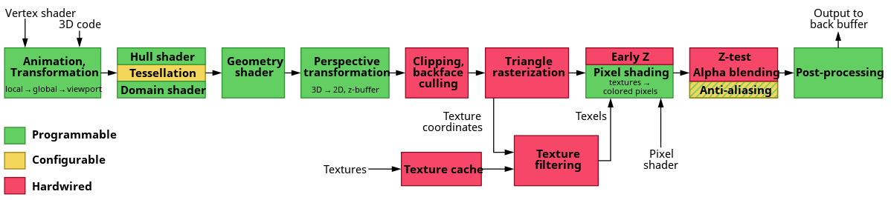

https://en.wikipedia.org/wiki/File:3D-Pipeline.svg

# vkCmdDrawMeshTasksEXT

**vkCmdDrawMeshTasksEXT** is the simplest as it functions the same as vkCmdDispatch, but dispatches the mesh or task shader in a graphics pipeline with the specified workgroup counts, rather than a compute shader.

Task or Mesh? It depends.

```

pipelineInfo.stageCount = 3;

stages[0].stage = VK_SHADER_STAGE_TASK_BIT_NV;

stages[0].module = m_shaderManager.get(shaders.task);

stages[0].pNext = rss_info_ptr;

stages[1].stage = VK_SHADER_STAGE_MESH_BIT_NV;

stages[1].module = m_shaderManager.get(shaders.task_mesh);

stages[1].pNext = rss_info_ptr;

stages[2].stage = VK_SHADER_STAGE_FRAGMENT_BIT;

stages[2].module = m_shaderManager.get(shaders.mesh_fragment);

stages[2].pNext = nullptr;

```

# MeshLet

### What is a meshlet

Subdivide your meshes into small groups of vertices/primitives during the asset building phase.

* Up to 256 vertices/primitives (typical: 128/128)
* Typically, 1 MS workgroup processes 1 meshlet (AMD prefers large workgroups, Maybe not for AMD)
* 1 TS invocation ∼ 1 meshlet

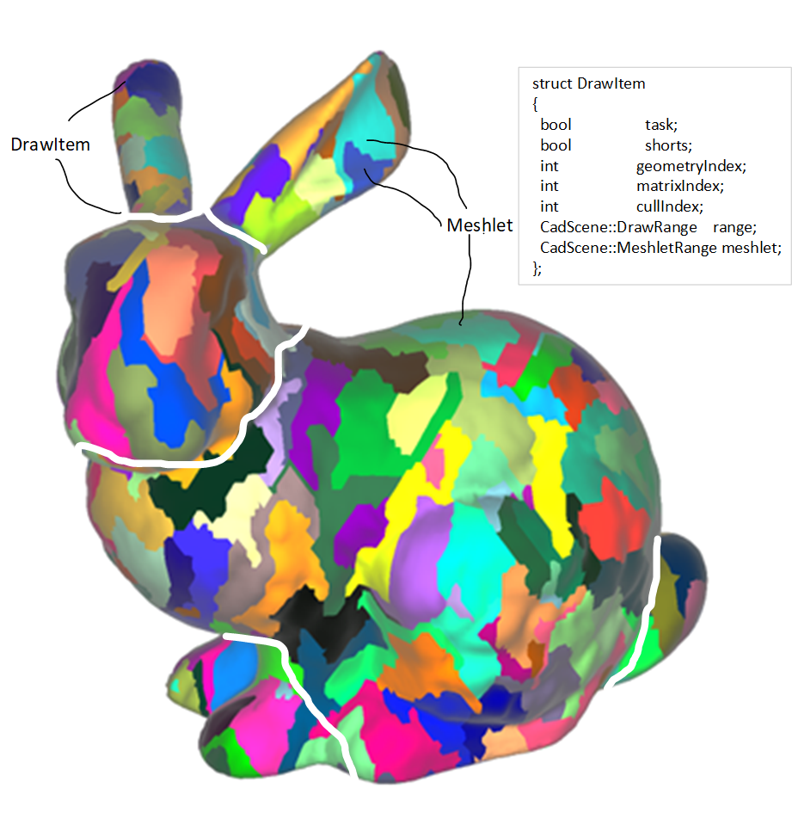

### Meshlet indexing

Vertex: unchanged;

Three buffers replace index buffer:

* Meshlet buffer
* Vertex index list
* Primitive index list

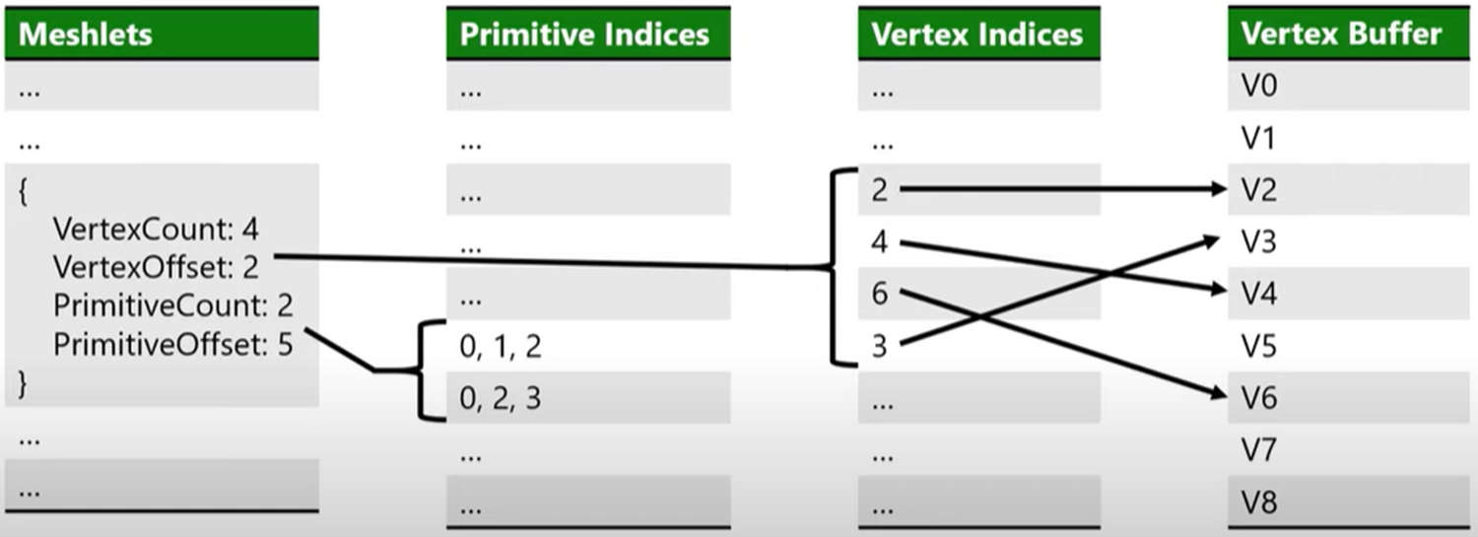

# Reinventing the Geometry Pipeline: Mesh Shaders in DirectX 12 | Shawn Hargreaves | DirectX Dev Day

# Mesh Shader basic

Task shader: How many mesh shader workgroups do you want(How many do you want for Task shader?)?

Mesh shader: Usea compute-like programming model to feed the rasterizer directly(? No fix function between these two?)

Task shader execution

* 1 invocation ∼ 1 meshlet
* Use EmitMeshTasksEXT to launch mesh workgroups

Mesh shader execution

* 1 invocation ∼ 1-2 vertex/primitive
* Use SetMeshOutputsEXT to allocate output arrays
* Write to output arrays
* Follow driver preferences!

Mesh shader driver preferences

* NVidia: small workgroups, more vertices/primitives per invocation
* AMD: large workgroups, 1 vertex/primitive per invocation
* Use a compile-time loop to match both!

# Vertex shader vs Mesh Shader

### D3D vertex shader

VS_OUTPUT main(VS_INPUT input)

{

**VS_OUTPUT Output**;

float4 pos = float4(input.vPos, 1.0f);

// object space to homogeneous projection space

pos = mul(pos, mWorld);

pos = mul(pos, View);

pos = mul(pos, Projection);

Output.Position = pos;

// Just pass through the color data

Output.Color = float4(input.vColor, 1.0f);

return Output;

}

### Vulkan vertex shader

layout (location = 0) in vec3 inPos;

layout (location = 1) in vec3 inColor;

layout (binding = 0) uniform UBO

{

mat4 projectionMatrix;

mat4 modelMatrix;

mat4 viewMatrix;

} ubo;

layout (location = 0) out vec3 outColor;

out gl_PerVertex

{

vec4 gl_Position;

};

void main()

{

outColor = inColor;

gl_Position = projectionMatrix * viewMatrix * modelMatrix * vec4(inPos.xyz, 1.0);

}

### First mesh shader(hlsl): cube

(HLSL sample from: https://www.youtube.com/watch?v=CFXKTXtil34)

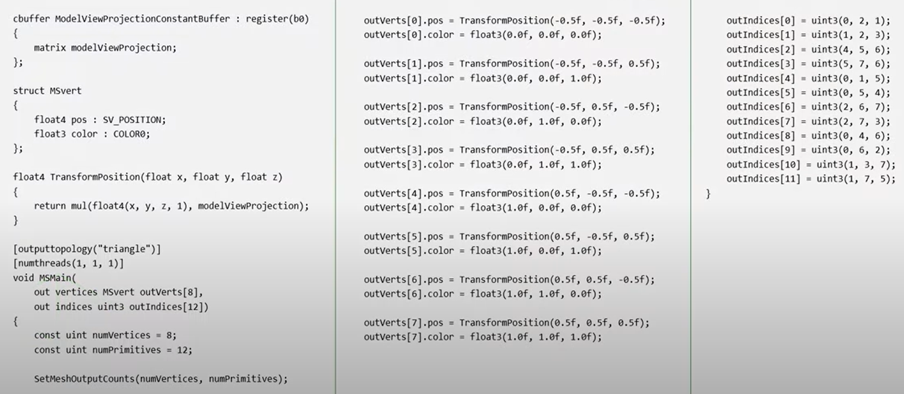

### Better mesh shader(hlsl): cube

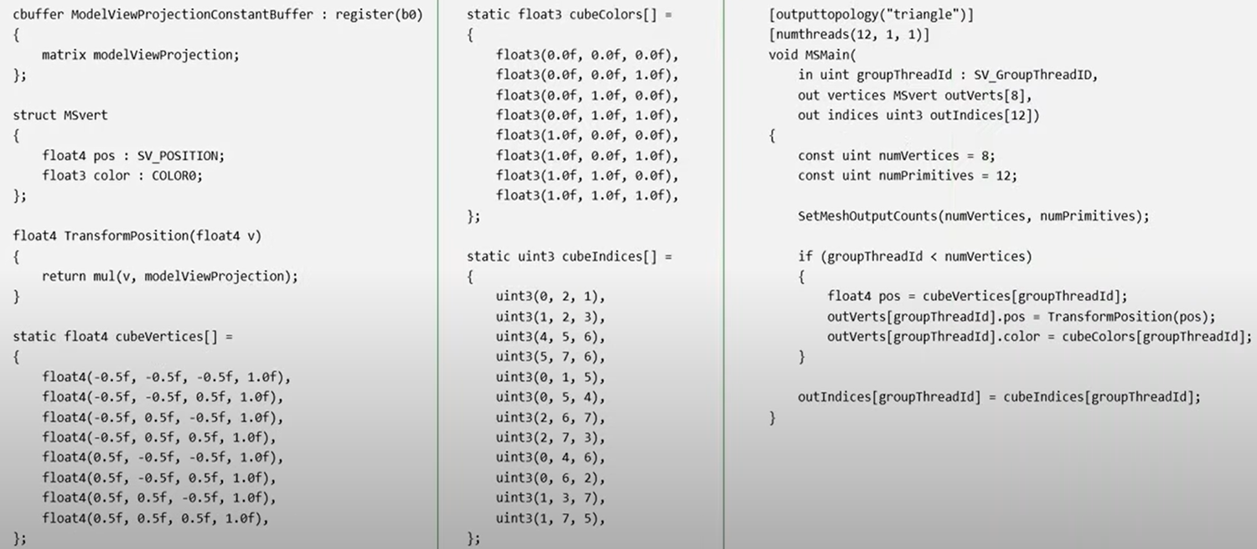

### Mesh Shader with meshlet(hlsl)

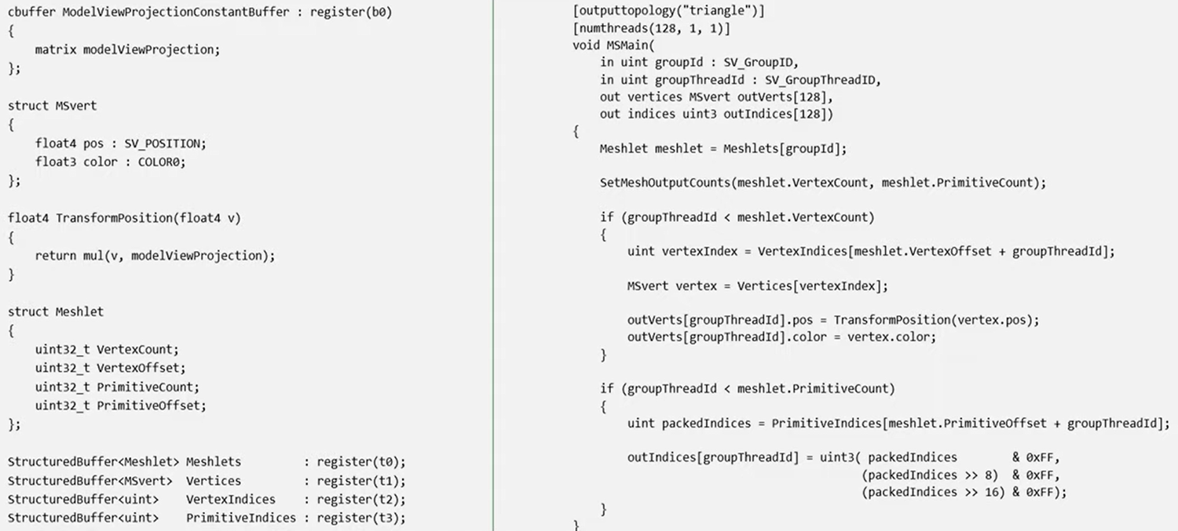

# Task shader and Mesh Shader

Task workgroup size

### Only Mesh Shader

Case 1: One meshlet per one mesh thread work group (One meshlet per one thread):

vkCmdDrawMeshTasksNV(commandBuffer, uint32_t(mesh.meshlets.size()), 0);

layout(local_size_x = 1, local_size_y = 1, local_size_z = 1) in;

<https://github.com/zeux/niagara/blob/7ad941833f5bd23f19ea667a3b2cc3911520d20b/src/shaders/meshlet.mesh.glsl>

Case 2: One meshlet per mesh thread work group (One meshlet per 32 threads):

vkCmdDrawMeshTasksNV(commandBuffer, uint32_t(mesh.meshlets.size()), 0);

layout(local_size_x = 32, local_size_y = 1, local_size_z = 1) in;

<https://github.com/zeux/niagara/blob/2898caaaf14f1c2c96f31eef8409f2d83adff53d/src/shaders/meshlet.mesh.glsl>

### Task shader + Mesh Shader example 1

Task shader: One meshlet per task thread

1), Task

* Number of task shader Workgroups:
  + vkCmdDrawMeshTasksNV(commandBuffer, uint32_t(mesh.meshlets.size()) / 32, 0);
* Work group size:
  + layout(local_size_x = 32, local_size_y = 1, local_size_z = 1) in;

2), Meshlet addressing:

uint ti = gl_LocalInvocationID.x;

uint mgi = gl_WorkGroupID.x;

uint mi = mgi * 32 + ti;

3), output:

gl_TaskCountNV (How many meshlet are generated by this task workgroup, number of workgroups for mesh shader.) gl_TaskCountNV is a work group variable.

(<https://github.com/zeux/niagara/blob/fa3d81dfda345520f48accf70da7cb4bcc1b1583/src/shaders/meshlet.task.glsl>)

Mesh shader: One meshlet per one mesh thread work group

* Number of mesh shader Workgroups:
  + sum of all(gl_TaskCountNV)?
* Work group size:
  + layout(local_size_x = 32, local_size_y = 1, local_size_z = 1) in;

<https://github.com/zeux/niagara/blob/fa3d81dfda345520f48accf70da7cb4bcc1b1583/src/shaders/meshlet.mesh.glsl>

# Culling

Conventional culling (based on vertex + fragment) can be performed by:

* software at the level of an entire draw call
* or by hardware on a per-primitive basis only after all the vertices of a primitive have been shaded(after vertex shader, before rasterization),
* but there are no in-between options.

Mesh shader culling can be performed by:

* software at the level of an entire draw call
* a per-primitive basis: back face, frustum, subpixel
* Cluster culling

### Backface culling





https://stackoverflow.com/questions/243945/calculating-a-2d-vectors-cross-product

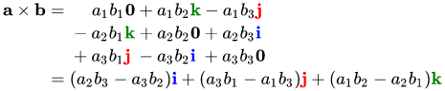

*// back face culling*

*vec2 ab = b.xy - a.xy;*

*vec2 ac = c.xy - a.xy;*

*float cross_product = ab.x * ac.y - ab.y * ac.x;*

*if (cross_product * winding < 0) return false;*

#if USE_BACKFACECULL

// back face culling

vec2 ab = b.xy - a.xy;

vec2 ac = c.xy - a.xy;

float cross_product = ab.x * ac.y - ab.y * ac.x;

#if IS_VULKAN

// Vulkan's upper-left window origin means that screen coordinates

// are reversed relative to OpenGL's. Reverse the sign of the

// cross-product to compensate.

cross_product = -cross_product;

#endif

if (cross_product * winding < 0) return false;

#endif

#if USE_VIEWPORTCULL || USE_SUBPIXELCULL

// compute the min and max in each X and Y direction

vec2 pixelMin = min(a,min(b,c));

vec2 pixelMax = max(a,max(b,c));

#endif

#if USE_VIEWPORTCULL

// viewport culling

if (frustum && ((pixelMax.x < 0) || (pixelMin.x >= scene.viewportf.x) || (pixelMax.y < 0) || (pixelMin.y >= scene.viewportf.y))) return false;

#endif

#if USE_SUBPIXELCULL

if (pixelBboxCull(pixelMin, pixelMax)) return false;

#endif

### Frustum culling

### Subpixel culling

### Cluster culling:

The idea is “Cull entire clusters which are completely back-facing”.

<https://gpuopen.com/learn/geometryfx-1-2-cluster-culling/>

<http://advances.realtimerendering.com/s2015/aaltonenhaar_siggraph2015_combined_final_footer_220dpi.pdf>

https://cgvr.cs.uni-bremen.de/teaching/cg_literatur/clustered_backface_culling.pdf

https://gitea.yiem.net/QianMo/Real-Time-Rendering-4th-Bibliography-Collection/raw/branch/main/Chapter%201-24/[1630]%C2%A0[Computer%20Graphics%20Forum%201993]%20The%20Cone%20of%20Normals%20Technique%20for%20Fast%20Processing%20of%20Curved%20Patches.pdf

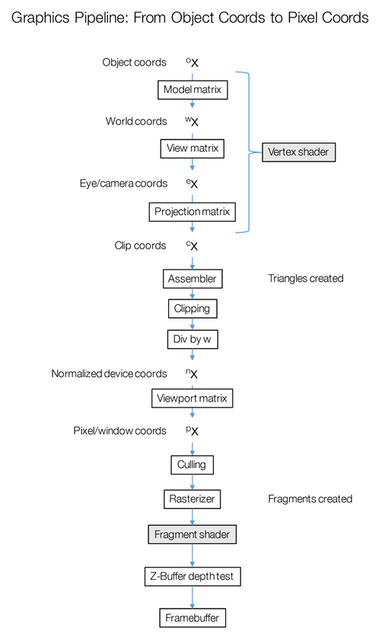

Meshlet culling:

https://www.youtube.com/watch?v=KckRq7Rm3Mw

Cluster culling:

http://advances.realtimerendering.com/s2015/aaltonenhaar_siggraph2015_combined_final_footer_220dpi.pdf

occlusion culling

Cone culling:

https://github.com/zeux/niagara/blob/fa3d81dfda345520f48accf70da7cb4bcc1b1583/src/shaders/meshlet.task.glsl

Meshlet culling

https://computergraphics.stackexchange.com/questions/11060/what-are-mesh-clusters-hierarchical-cluster-culling-with-lod-triangle-c

### 

### Stats data

if (laneID == 0) {

gl_PrimitiveCountNV = primCount;

#if USE_STATS

atomicAdd(stats.meshletsOutput, 1);

atomicAdd(stats.trisOutput, primCount);

atomicAdd(stats.attrInput, vertCount);

atomicAdd(stats.attrOutput, vertCount);

#endif

}

# Mesh shaing Possiblity

<https://www.reedbeta.com/blog/mesh-shader-possibilities/>

# Loop unrolling(Compile time loop)

CPU: http://spraetor.github.io/2015/12/26/compile-time-loops.html

GPU:

https://etd.ohiolink.edu/apexprod/rws_etd/send_file/send?accession=osu1253131903&disposition=inline

### 